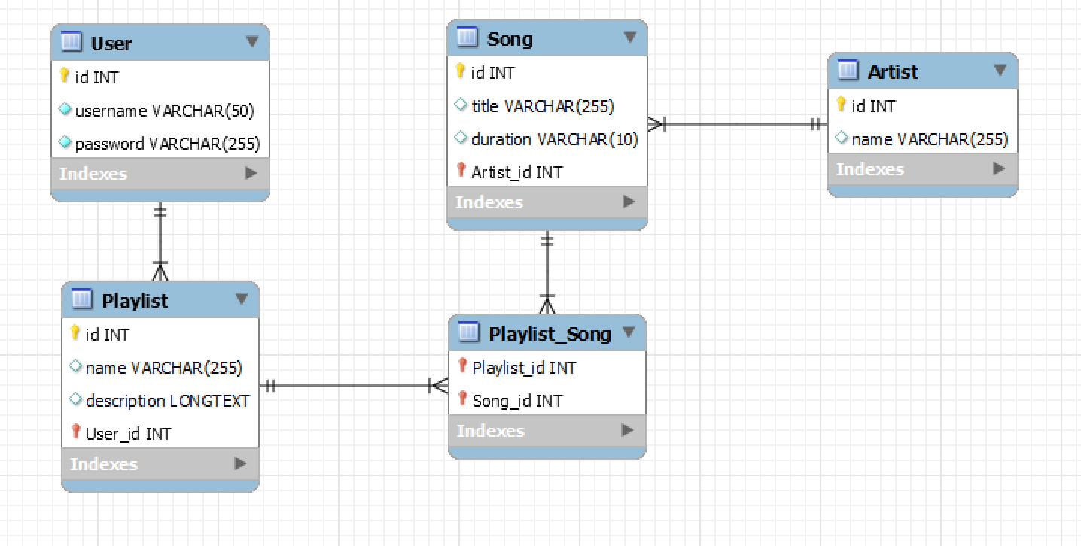

**Artist**

id: Primary Key

name: Artist's name

**Song**

id: Primary Key

title: Song title

duration: Song duration

artist_id: Foreign Key referencing artist(id)

**User**

id: Primary Key, Auto-increment

username: Username, Unique

password: Password

**Playlist**

id: Primary Key, Auto-increment

name: Playlist name

description: Playlist description

user_id: Foreign Key referencing user(id)

**Playlist_Song**

playlist_id: Foreign Key referencing playlist(id)

song_id: Foreign Key referencing song(id)

Primary Key: Composite Key of playlist_id and song_id

**Normalization Check**

1. **First Normal Form (1NF)**:
   * Each table has a primary key.
   * All columns contain atomic values.
   * Each column contains values of a single type.
2. **Second Normal Form (2NF)**:
   * All non-key columns are fully functionally dependent on the primary key in each table.
   * The **song** table has **title**, **duration**, and **artist_id** which are all fully dependent on the **id** primary key.
   * The **playlist** table has **name**, **description**, and **user_id** which are fully dependent on the **id** primary key.
   * The **playlist_song** table's composite key ensures full dependency on both **playlist_id** and **song_id**.
3. **Third Normal Form (3NF)**:
   * All attributes in each table are directly dependent on the primary key.
   * There are no transitive dependencies in any of the tables.
   * The **song** table's **artist_id** is a foreign key, maintaining direct dependency without transitive dependency.